### **Executive Summary**

This feasibility study addresses the lack of accessibility in e-learning platforms for visually impaired learners by proposing the development of Hearis, an Adaptive Learning Management System (LMS) powered by AI-based Natural Language Processing (NLP) and multi-modal haptic feedback. The system integrates speech recognition, text-to-speech, and tactile cues to provide intuitive, non-visual interaction, enabling learners to navigate and comprehend digital content independently. Its main objective is to bridge the accessibility gap in higher education by fostering inclusion and empowerment through technology.

The scope of the study covers the design, iterative development, and evaluation of the LMS using the Agile Development Methodology and guided by the ISO/IEC 25010 quality model. However, the project is delimited to visually impaired learners and constrained by resource availability, device compatibility, and academic timelines. Despite these risks and limitations, the system offers a credible and innovative solution to enhance accessibility, usability, and inclusivity in higher education e-learning environments.

**CHAPTER 1 BUSINESS PROFILE   
ACCENDO**

The name “Accendo” originates from the Latin word meaning *“to ignite,” “to illuminate,” or “to inspire.”* This name reflects the company’s purpose of bringing light and empowerment through accessible education.

Aligned with our vision to be a pioneer in inclusive digital education, Accendo symbolizes the spark of knowledge and innovation that illuminates learning opportunities for visually impaired learners. It represents our commitment to making accessibility and equity central to the future of e-learning systems.

In harmony with our mission, Accendo embodies our goal to design AI-powered adaptive learning systems that enable visually impaired students to learn independently and confidently. Through the integration of Natural Language Processing and multi-modal haptic feedback, Accendo seeks to ignite change within the education technology community—fostering fairness, inclusivity, and a brighter path toward accessible digital learning.

**Nature of Business**

Our company operates in the Educational Technology (EdTech) industry, focusing on the development of accessible and adaptive e-learning systems for visually impaired learners. The core business revolves around the design, manufacturing, and delivery of digital solutions that combine Artificial Intelligence (AI), Natural Language Processing (NLP), and Multi-Modal Haptic Feedback technologies to make learning more inclusive and engaging.

The company integrates three major business areas:

1. Manufacturing – Development and integration of adaptive learning management software, AI-powered voice interaction tools, and haptic feedback systems that enhance accessibility for visually impaired learners.
2. Trading – Distribution and licensing of adaptive learning software packages, accessibility modules, and assistive devices to schools, universities, and government agencies.
3. Service – Providing technical support, user training, accessibility consulting, and continuous maintenance to ensure optimal system performance and compliance with international standards for inclusive education.

Through these combined areas, the company aims to promote digital inclusion and equal educational opportunities for learners with disabilities, aligning with global educational accessibility initiatives.

**Company Vision and Mission Statements**

**VISION**

To be recognized as a pioneer in inclusive digital education by creating opportunities for visually impaired learners through AI and haptic-based technologies, making accessibility and equity a core part of future e-learning systems.

**MISSION**

Accendo strives to make e-learning more inclusive by designing adaptive learning management systems that use AI-powered language processing and haptic feedback. Our goal is to help visually impaired learners study independently, support teachers with accessible tools, and encourage the education technology community to focus on accessibility and fairness in digital learning.

**Company Objectives**

In the short term, the company aims to develop and pilot an AI-powered Adaptive Learning Management System (ALMS) that integrates natural language processing and multi-modal haptic feedback to enhance accessibility for visually impaired learners. Within the first two years, it seeks to establish partnerships with local educational institutions and accessibility organizations for testing and deployment. Alongside system development, the company will focus on building a strong brand identity as an innovator in accessible education technology in the Philippines and forming a multidisciplinary team skilled in artificial intelligence, user accessibility design, and software development.

For the long term, the company envisions expanding the implementation of the adaptive LMS across schools and universities nationwide, ensuring that visually impaired students can access high-quality, inclusive education. It plans to enhance the system to accommodate learners with other disabilities, introducing features that promote universal accessibility. The company also intends to launch a subscription-based platform for wider market access and global adoption, positioning itself as a leading provider of accessibility-driven educational technology in Southeast Asia. Continuous improvement will remain a core focus, guided by the ISO/IEC 25010 Quality Standard to ensure usability, reliability, and accessibility across all system components.

**Company Logo** 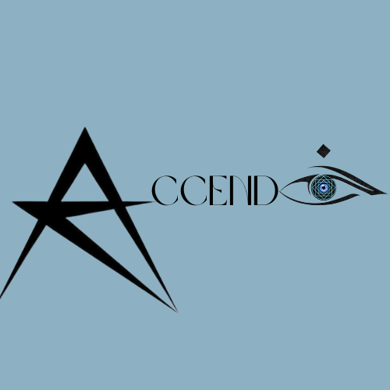

**Figure 1.** *Official Logo of Accendo Company*

The Accendo logo tells a story of light, vision, and purpose. It embodies the company’s mission to illuminate the path of learning for visually impaired individuals through the power of innovation and technology. The letter A, formed as a radiant star, captures the spirit of enlightenment and guidance. It symbolizes how Accendo strives to spark curiosity, inspire confidence, and lead learners toward greater understanding.

At the opposite end, the letter O, creatively shaped as an eye with a diamond above it, reflects clarity, awareness, and the brilliance of knowledge. The eye represents perception and insight, while the diamond above it signifies the precious value of learning and the pursuit of intellectual growth. Together, these elements form a visual harmony that expresses the company’s belief that knowledge should shine for everyone, regardless of limitation.

Through its elegant typography and thoughtful symbolism, the Accendo logo stands as a beacon of inclusivity and empowerment. It reflects the company’s vision of transforming education into an experience guided by light, strengthened by understanding, and enriched by accessibility.

**Company Location** Accendo is located in Ligid Tipas, Sapang Viejo, Taguig City, Metro Manila, Philippines, a community that fosters growth and innovation. Its strategic location provides accessibility to nearby institutions and potential partners that support technological development and inclusive education initiatives.

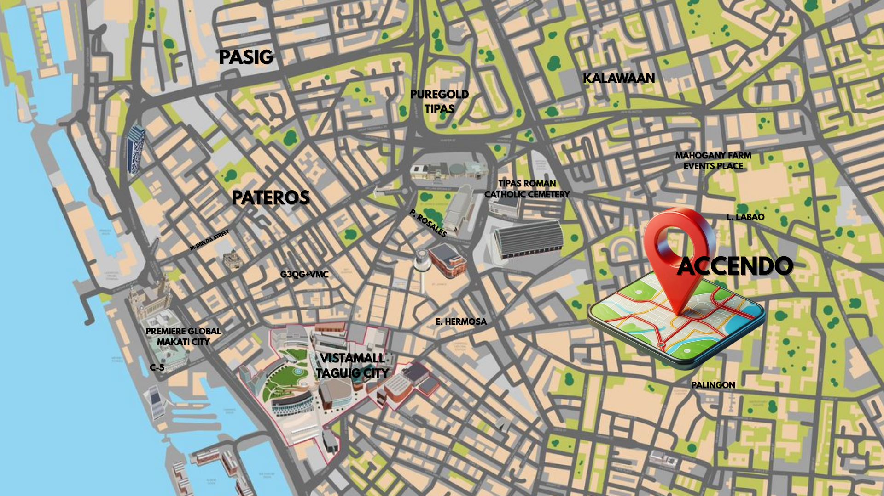

**Figure 2.** *Location Sketch of Accendo Company situated in Ligid Tipas, Sapang Viejo, Taguig City, Metro Manila, Philippines.*

**Product/Service Description**

Accendo is a technology-driven company dedicated to designing and developing accessible and intelligent learning platforms for visually impaired learners. It focuses on bridging the gap between innovation and inclusivity by providing adaptive educational tools that empower learners to achieve academic growth without the barriers of visual limitations.

Through the integration of Artificial Intelligence (AI), Natural Language Processing (NLP), and Multi-Modal Haptic Feedback, Accendo transforms traditional e-learning into a more inclusive, interactive, and human-centered experience. These advanced technologies work together to create a system that not only supports accessibility but also personalizes the learning journey of every user.

The company’s flagship product, the Adaptive Learning Management System (LMS) for the Visually Impaired, introduces a revolutionary approach to digital education. It provides a fully interactive environment that caters to learners with visual impairments through innovative features such as:

* Voice-based interactions that allow seamless and hands-free navigation of learning modules.
* Text-to-speech and speech recognition technologies that enable natural and effective communication between the learner and the system.
* Haptic feedback integration that delivers tactile learning cues, allowing users to engage through the sense of touch.
* AI-driven content adaptation that adjusts lessons, assessments, and feedback based on each learner’s individual pace and progress.

By combining technology and empathy, Accendo envisions a world where no learner is left behind, regardless of their physical abilities. The Adaptive LMS stands as both a technological product and a service platform, representing Accendo’s commitment to inclusive innovation and its mission to make education truly accessible for all.